Project 4: Cloud Operations Plan for BallotOnline
Matthew Santiago
University of Maryland Global Campus
CCS 630 Cloud Infrastructure Planning, Design, and Configurations
Alan Castillo
March 14, 2025

Executive Summary
BallotOnline engineers have successfully moved our initial infrastructure into Amazon Web Services (AWS) cloud which has provided scalability, reliability and cost efficiency. This Cloud Operations Plan will detail the deployment and management of the AWS Service Catalog. Administrator and end user guides were created and included to ensure that the cloud services are easy to use and run in compliance with BallotOnline policies. The use of AWS Service Catalog will allow administrators to manage service portfolios while letting employees access pre-approved resources easily. Also included is a training presentation to help employees understand and use the AWS Service Catalog.
Overview
The AWS Service Catalog is a key tool that we have decided to use, because it provides a centralized and standardized way of deploying cloud resources that administrators ensured meets BallotOnline policies but also reduces the difficulty to deploy resources for end-users. The following plan is for the deployment of the backups and archiving service, which we covered in the previous reports. The service catalog has a portal for users and a management system for administrators to manage cloud operations. Our key objectives with this system was to guarantee data accuracy, maximize resource usage and provide clear documentation. With this approach we were able to develop a reliable and user-friendly cloud infrastructure that will enable BallotOnline employees to innovate and provide safe and secure elections.
AWS Service Catalog
Overview
The AWS Service Catalog helps BallotOnline to collect and control a set of AWS services, so that only the allowed combinations are used (Amazon Web Services, 2023). The following documentation examples are from the deployment of our cloud backups and archiving service. The Service Catalog configurations we implemented makes sure that data is secure, it can be scaled, and it is compliant with industry standards (Amazon Web Services, 2023). Configuring the portfolio in the service catalog like this reduces the risk through the use of predefined templates.
Configuration and Deployment
- Create Users and Groups
  - Go to IAM in the AWS console.
  - Create a new group: BackupOperators
  - Attach the policies: AmazonS3FullAccess and ServiceCatalogEndUserFullAccess
  - Create a new user
    - Give user AWS Management Console access
    - Set a Custom password: UMGCCloud123
    - Add user to the BackupOperators group
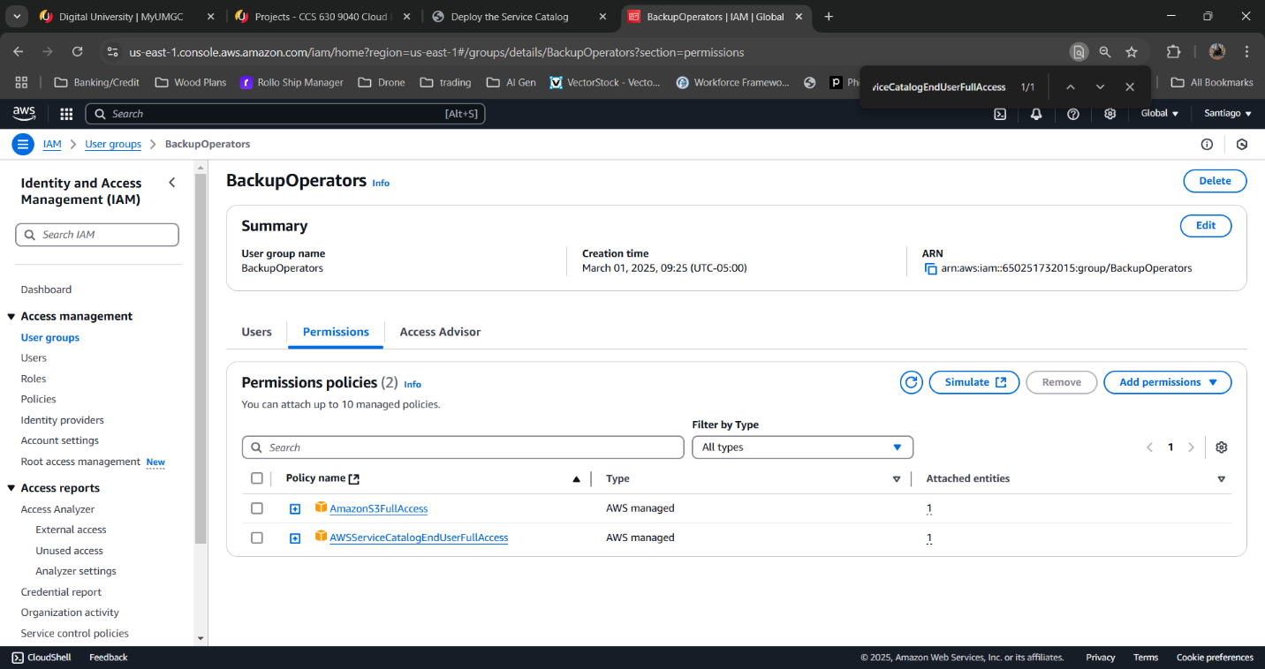
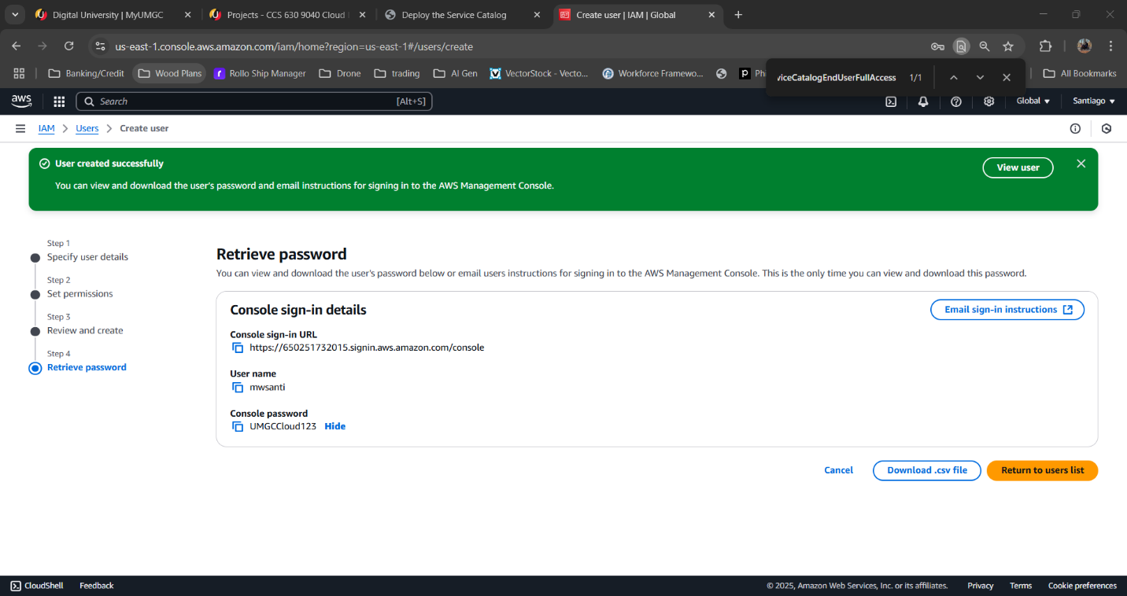
- Create a Portfolio
  - Create a new portfolio:
    - Name: CCA630
    - Description: CCA630 Lab
    - Owner: Your name
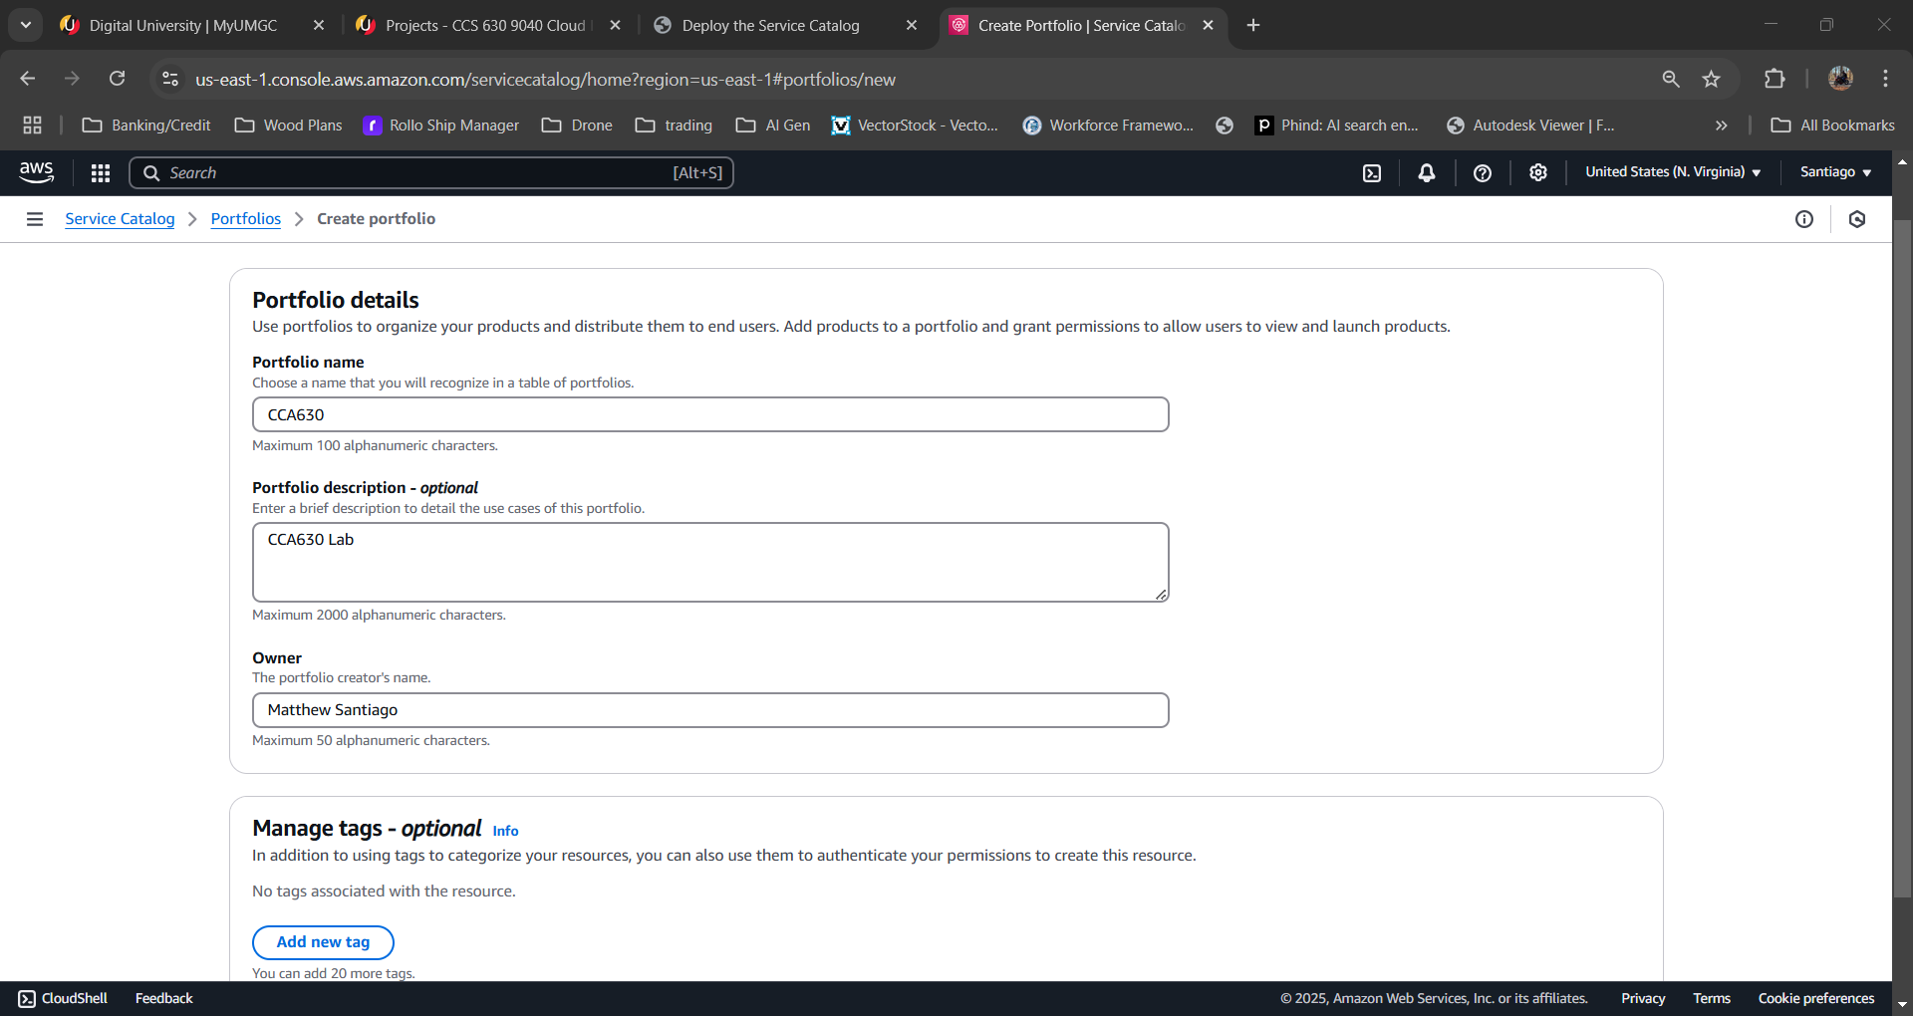
- Add a New Product
  - Go to Products list and upload new product.
  - Product details:
    - Product name: Backup and Archiving
    - Description: Backups and Archiving for BallotOnline
    - Provided by: BallotOnline
    - Vendor: Amazon AWS
  - Support info:
    - E-mail contact: Your email
    - Support link: http://ballotonline.com/support
    - Support description: Support
  - Add URL for the template
    - https://s3.amazonaws.com/cloudformation-templates-us-east-1/S3_Website_Bucket_With_Retain_On_Delete.template
    - Version title: AWS
    - Description: S3 Bucket
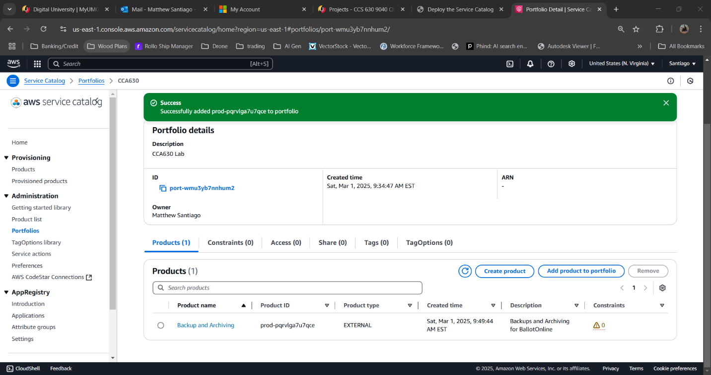
- Add Users and Grant Access
  - Open the Portfolio CCA630
  - Click user, groups, and roles
  - Click Add user, group or role
    - Select BackupOperators and click Add Access
  - Confirm the group can launch the product
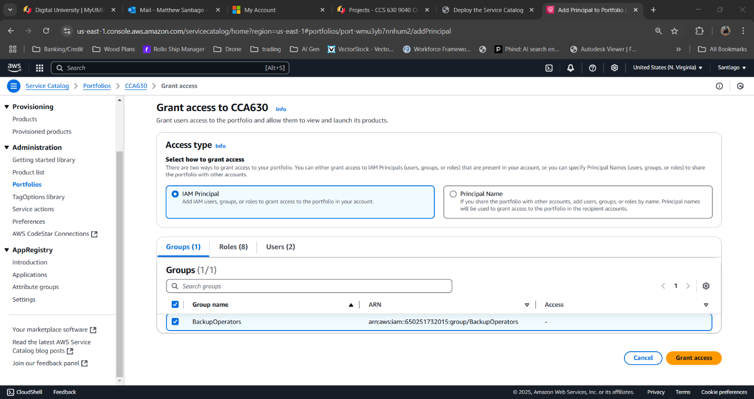
Cloud Operations End-User Guide
Overview
The Cloud Operations End-User Guide will allow employees to access and deploy our cloud services from the AWS Service Catalog without having to have technical skills. The guide is based on our proof od concept deployment “CCA630 portfolio” and provides step by step guidance on how to request and provision pre-approved resources.
Usability of AWS Service Catalog
The following instructions show how to access and use the AWS Service Catalog to deploy the cloud backups and archiving service.
- Log in to the AWS Management Console: https://console.aws.amazon.com/
  - Enter your BallotOnline username and password “UMGCCloud123”
- Go to the AWS Service Catalog by searching for “Service Catalog” under Services
- On the Service Catalog portal, select the CCA630 portfolio to see the available services.
- Deploy the Cloud Backups and Archiving Service
  - In CCA630 select Backups and Archiving and click launch product
  - Wait till fully deployed
- Use the S3 Bucket by going to S3 page. This can be found by searching S3 in services search box
  - Find the new S3 bucket and use for backup or archiving
Cloud Operations Admin Guide
Overview
The Admin Guide will provide administrators with the info to manage and implement services from the AWS Service Catalog. The AWS Service Catalog is a centralized platform for provisioning cloud resources that have been approved in advance, to reduce risk, and increase efficiency for end users. This guide is based on our service “Backups and Archiving”, which uses Amazon S3 for reliable and secure backups and Amazon S3 Glacier for cost efficient long term storage. Admins will learn how to set up the Service Catalog, launch services and include them in the portfolio.
Configuration and Deployment of AWS Service Catalog
- Create Users and Groups
  - Go to IAM in the AWS console.
  - Create a new group: BackupOperators
  - Attach the policies: AmazonS3FullAccess and ServiceCatalogEndUserFullAccess
  - Create a new user
    - Give user AWS Management Console access
    - Set a Custom password: UMGCCloud123
    - Add user to the BackupOperators group


- Create a Portfolio
  - Create a new portfolio:
    - Name: CCA630
    - Description: CCA630 Lab
    - Owner: Your name

- Add a New Product
  - Go to Products list and upload new product.
  - Product details:
    - Product name: Backup and Archiving
    - Description: Backups and Archiving for BallotOnline
    - Provided by: BallotOnline
    - Vendor: Amazon AWS
  - Support info:
    - E-mail contact: Your email
    - Support link: http://ballotonline.com/support
    - Support description: Support
  - Add URL for the template
    - https://s3.amazonaws.com/cloudformation-templates-us-east-1/S3_Website_Bucket_With_Retain_On_Delete.template
    - Version title: AWS
    - Description: S3 Bucket

- Add Users and Grant Access
  - Open the Portfolio CCA630
  - Click user, groups, and roles
  - Click Add user, group or role
    - Select BackupOperators and click Add Access
  - Confirm the group can launch the product

- Monitor with AWS CloudWatch
  - Go to https://console.aws.amazon.com/cloudwatch/
  - Click Alarms, then Create Alarm
  - Pick Estimated Charges, set a limit and create it
Limitations and Resources
Throughout this process we have learned of a couple limitations to our use of the Service Catalog. First, it can cost a lot to store a lot of data in Amazon S3 for the data we a lot. This means that we have to keep a close eye on the cost with AWS CloudWatch to avoid getting out of control charges. Second, the process of creating and managing the Service Catalog, users, and portfolios can be time consuming and complex process. Third, using AWS specific services can make it harder to move to other cloud providers in the future. These limitations do not require use to reevaluate the cloud but we should have a plan and monitor to avoid any problems.
Also as employees begin to use these services there will naturally be questions. AWS provides easy to find guides and examples for users or admins to use when questions arise for all their services (Amazon Web Services, 2024). In addition to AWS documentation, we created a BallotOnline support page, main support email, and ticketing service which will be available for employees who need help. Using these resources will help our employees get problems fixed quickly and easily.
Summary
In conclusion, this Cloud Operations Plan shows how we successfully used AWS Service Catalog to manage the Backups and Archiving service. The End User Guide was designed to help employees navigate to pre-approved resources in the BallotOnline approved portfolio. The Admin Guide explains to our administrators how to set up, control, and monitor the Service Catalog. Monitoring the catalog and user deployments will be done by using AWS CloudWatch to monitor and control costs. This deployment style will create safe elections and ensure the data collected and processed is secure to industry standard by letting automation control deployments.

References
Amazon Web Services. (2023). Amazon Web Services. Retrieved from What is Service Catalog?: https://docs.aws.amazon.com/servicecatalog/latest/adminguide/introduction.html
Amazon Web Services. (2024). Amazon Web Services. Retrieved from Amazon Web Services documentation: https://docs.aws.amazon.com/

